Let's Visit . . .
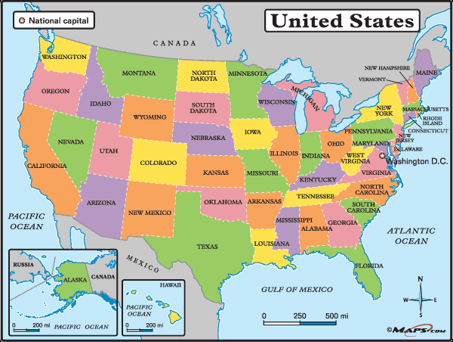

The United States of America

Use Google Earth to travel America, finding locations, then zooming in to find interesting things in each place!

- Read these directions.
- When you have finished, minimize this screen. Open it back up, if you need to remember a step.

FIRST . . .
Get a travel chart from the drawer.

NEXT . . .
Open Google Earth from your desktop (but finish reading these directions, first!)

STEP ONE: Type in your location.
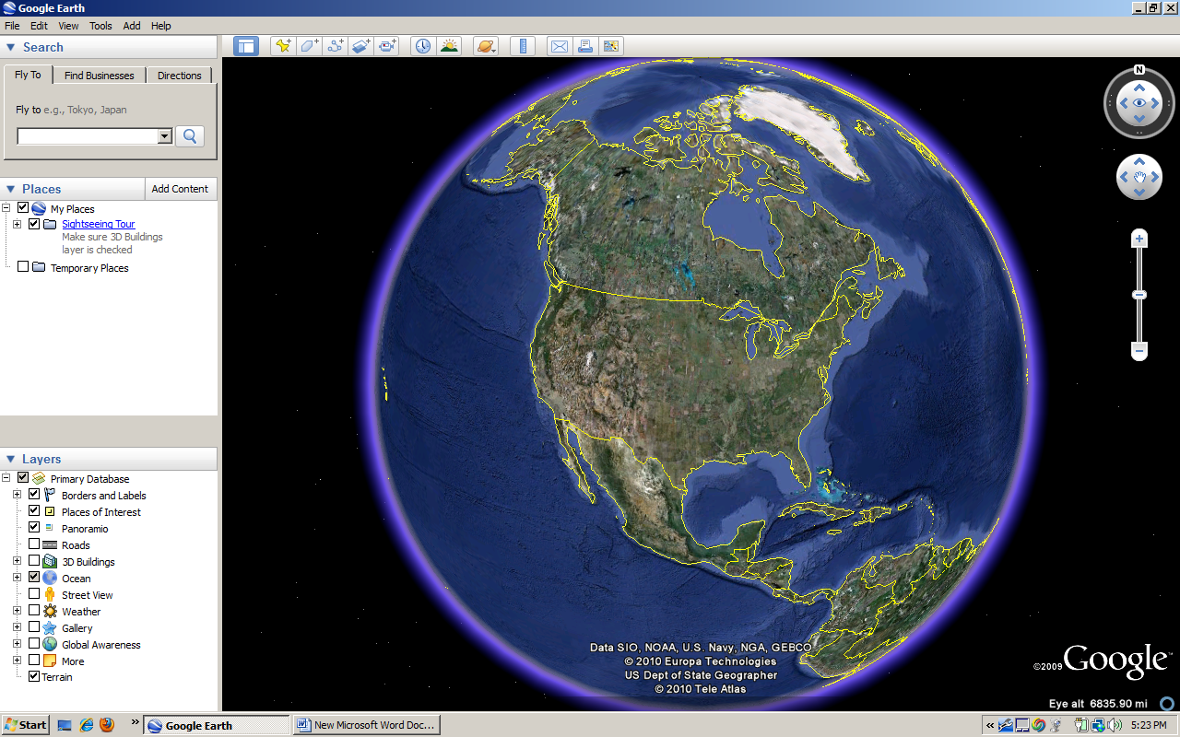

STEP TWO: Find Longitude, Latitude (at the bottom of the screen) 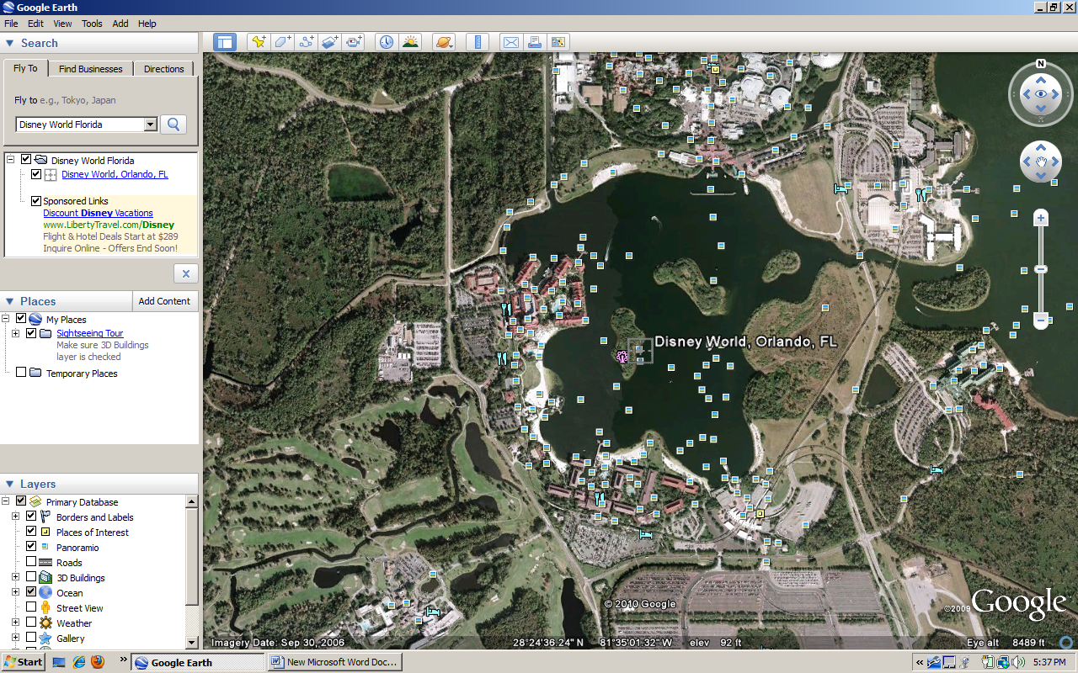STEP THREE: Zoom In on something interesting

When you’re finished, travel to the next destination!

When you’re finished, travel to the next destination!
HAPPY TRAVELS . . .

